**Sea Adventures- DevLog**Lyudmil Pashayanov

# Overview:

I am inspired to create a **Tower Defense**, **RPG**, **Strategy** game. Main idea is that you have your ship (*player*) in open waters (*level map*) and you have an island (main point of interest), somewhere on the level map, which must be ***defended***. Just like in “**Orcs Must Die**” the player, would be able to place ***defenses*** on the map, which will help him when the pirates (*enemies*) come. I would like to be able to introduce several types of ships, with which the player will be able to play with (*attacker, defender, carrier*), all of which will have different advantages and disadvantages. The level will be similar to a **Plants vs. Zombies** level, where there are several waves and the player needs to survive until the end.

# Target performance:

## Design:

* I would also like to create small economy within the game, which would be able to later monetize the game. For example, create a currency so important and valuable so that a player spends money on it.
* I would like to investigate and learn how I can create a game, which introduces different types of main characters (different ships), defenses, enemies and at the same type will be balanced to play. I would like to give the player to choose different style of gameplay, which I find challenging to do. That is why I would really like to research such type of game design.

# Economy good enough to monetize the game

## Currencies:

(Explain why soft and hard currencies are important).

**Upgrade points-** Granted at the beginning of a level. Used to create and upgrade defenses and upgrade your ship during the level. Upon a finished wave, more upgrade points are granted. If a level is failed, only half (has to be researched) the points are converted to coins and rewarded to the player. Upon winning a level, more upgrade points are granted and converted to coins.

**Diamonds**- The currency you pay 1x for starting a level in the game. You receive 1x **Diamond** upon winning a level. There will be max amount of this currency. It will recharge overtime. Could be bought with **real money**.

**Coins**- The currency you receive from the rest over **Upgrade points** you have when you finish a level. This mechanic of rewarding coins will prompt the users to play a level, while spending less **Upgrade points**, which will make the game harder and will force the user to play smart, plan out moves, spend less upgrading points.

## User Scenario:

In the user scenario below, you can see how the currencies are going to be rewarded and how the player will spend them.

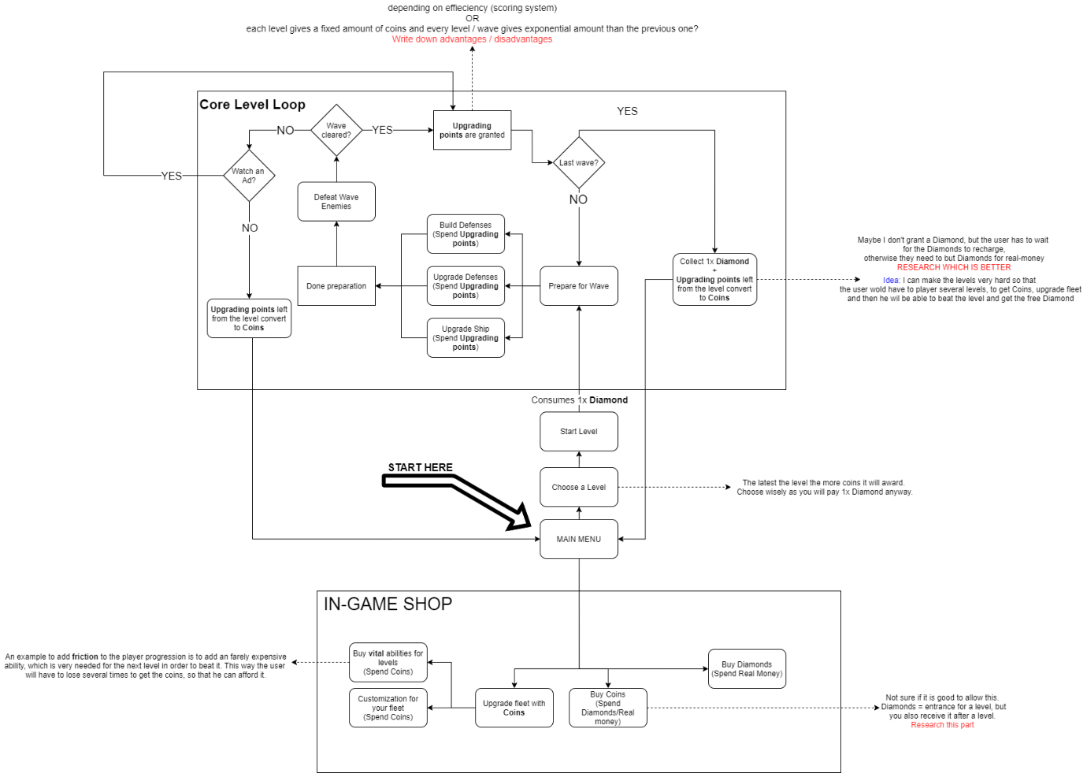

Figure : User scenario focused on monetization

## Core level Loop Of “Sea Adventures”:

### Start of a level:

Player loses 1x Diamond in order to start the level.  
The player starts with pre-determined amount of **upgrading points.**

### Preparation phase:

Player will have to prepare for the big waves of enemies coming to attack. The preparation consists of:

1. Upgrading your ship abilities/stats: By spending **upgrading points**.
2. Putting defenses on the map: By spending **upgrading points**.
3. Upgrading your already active defenses: By spending **upgrading points**.

### Wave phase:

During the wave, the player actively attacks incoming enemies and defends the main point of interest (island). While destroying enemies, the player receives **upgrading points**, which could be spend on the next preparation phase.

### Lose State:

In case the player fails to complete the level (dies), he is prompted to watch and **Ad** and continue where he left off (explain why this is good). If he refuses, certain amount of the (half) **upgrading points** are converted to **coins** and the player is sent to the main menu.

### Win State:

In case the player successfully beats the level, the one is rewarded with 1x **Diamond** and all his left-over **upgrading points** are converted to **coins**.

# Balanced Stats and gameplay design:

## Player Ship design (WIP):

### Overall stats:

1. Movement speed
2. Attack damage
3. Carriage amount (how many defenses you can place)
4. Health?
5. Shields?

### Carrier ship:

* Medium carriage amount.
* Medium movement speed.
* Medium attack damage

### Attacker:

* Medium movement speed.
* Big attack damage.
* Little carriage amount.

### Defender:

* Little attack damage
* Little/medium speed
* Big carriage amount

# To be decided:

1. ~~What platform do I aim for? It will be either PC or mobile, but I have not decided yet. If it is going to be mobile game, I will be restricted with amount of controls the user can use and I would have to focus on UI design a lot, which I am not sure if I want.~~
2. ~~If the levels of the game will be pre-designed~~ **~~OR~~** ~~they will be auto generated, with some values for difficulty being increased.~~
3. ~~Depending on the chosen platform, if the movement of the player will be “click on the screen to move there” or WASD controls.~~
4. If your player ship is shooting attacking enemies automatically or the player is aiming? If the game is going to be mobile, automatic shooting (Archero) will be easier on the player, but would as well give the feeling that the user has less control over the level and his actions.
5. What enemies should be there?
6. What defenses should be there?
7. What are the advantages and disadvantages of the different player ships (characters)?
8. ~~What upgrades there will be outside of the level? (maybe increasing your overall stat for one type of ship)~~
9. Find who is your user. Who likes this genre /type of games? What do those people like? Get good insight of your users. Personas: Strategy/Planning games players, who like medium fast paced games, where they have to plan their decisions but as well take new decisions on the go: <https://english.stackexchange.com/questions/196100/what-is-a-word-to-describe-the-character-of-someone-who-plans-his-actions-in-adv> / <https://en.wikipedia.org/wiki/Conscientiousness>
10. Should there be customization to the upgrades of your ship? How customization can be monetized?
11. Decide if it will be 3rd person camera or strategy game camera (top-view/ touch sides to control (League of legends)).

# Already decided:

1. I will develop a prototype for my economy and monetization of the game for a PC, with the idea that later on I will move the controls and game mechanics to fit a mobile device.
2. The levels will be pre-designed, as I would like to have **full control** on how fast the player will advance, so I can as well know how the player will spend his coins / money.
3. Both of the controls been implemented in the project and will be tested to see which one is liked more and suits the game. If the game is moved to mobile, “click to go” controls are more user-friendly, than little mobile joystick controller on the bottom corner of the screen.

8. Upgrades, which will be **essential and** **required** by the next levels if you want to pass it with ease. The user will be drawn more to actually invest real money for diamonds->coins and then upgrades (sold for coins), as the faster you get upgrades the faster you can progress the game. Also upgrading the appearance of your ship will be sold as well.

# Notes (pictures):

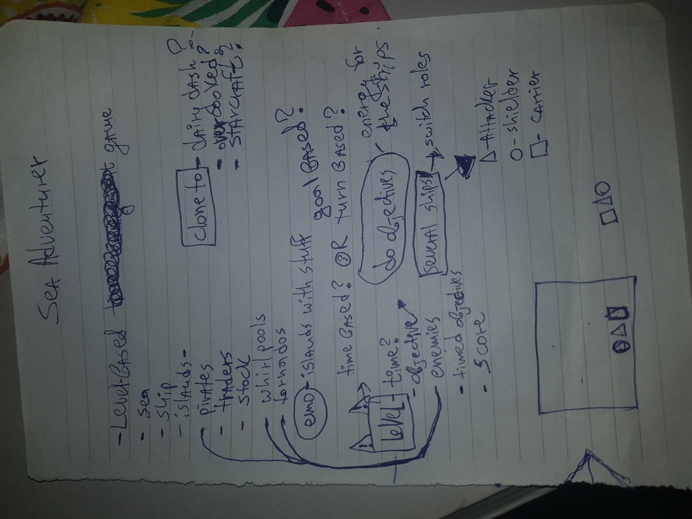

Figure - Brainstormed ideas on paper

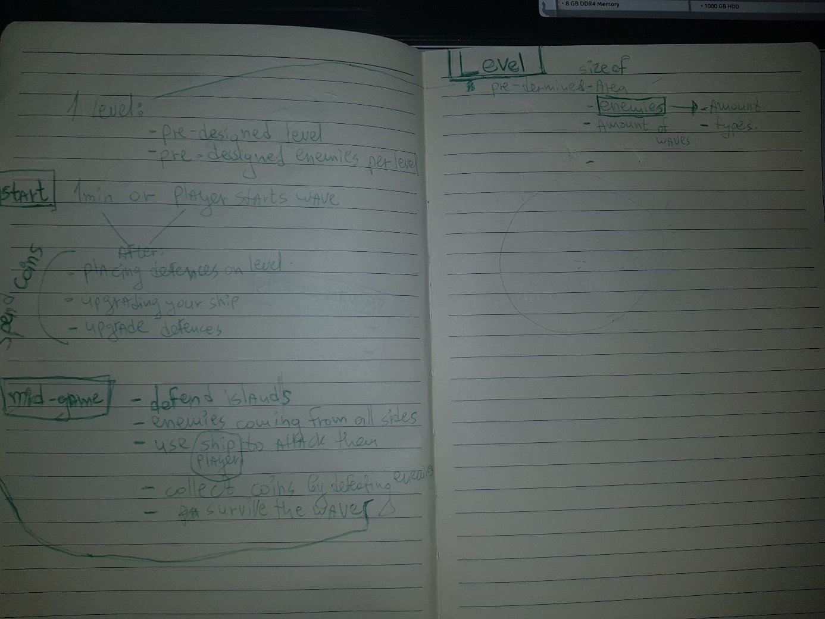

Figure - Core Loop notes

5 magical questions on the thing you are willing to work.

